Microsoft Windows desktop
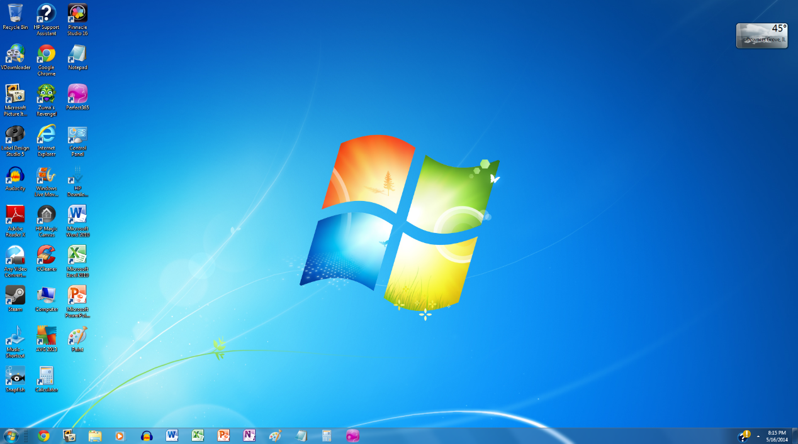
Disk Operating System – one of the first operating systems for the personal computer. When your turned the computer on all you saw was the command prompt which looked like. You hard to type all command.
DOS desktop
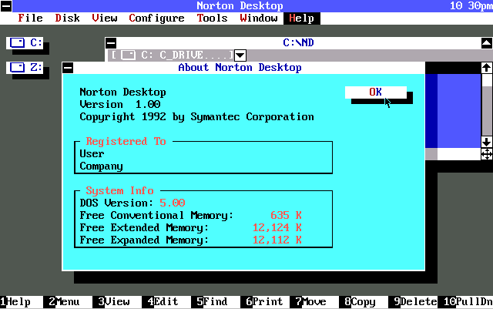
The windows operating system, a product of Microsoft, is a GUI (graphical user interface) operating system. Thus is a type of “user friendly” operating system.

MacOS desktop
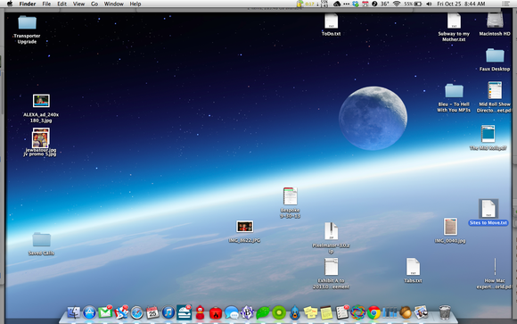
Macintosh, a product of Apple, has its own operating system with GUI and WIMP features.
Unix-Linux

(The PC version of Unix) – Unix and Linux were originally created with a command-line interface, but recently have added GUI enhancements.

